A Project Report

On

**“Blood Donor Management System: ROKTO LAGBE”**

For The Course

**“Software Development Project-I”**

By

**Monira Akter (IT-20003)**

**Md. Jubayer Alam (IT-20004)**

**Supervised by**

**Prof. Md. Shahin Uddin**

Professor, Department of ICT

Mawlana Bhashani Science & Technology University



**DEPARTMENT OF INFORMATION AND COMMUNICATION TECHNOLOGY**

**MAWLANA BHASHANI SCIENCE AND TECHNOLOGY UNIVERSITY, SANTOSH**

**Declaration**

This is to certify that the work presented in this project is carried out by the candidate under the supervision of **Prof. Md. Shahin Uddin** in the department of Information and Communication Technology, MBSTU, Tangail, Bangladesh. It is also declared that neither of this project has been submitted anywhere else for any degree or diploma. Information derived from the published and unpublished work of others has been acknowledged in the text and a list of references is given.

Signature of Supervisor

**Prof. Md. Shahin Uddin**

Professor

Department of ICT, MBSTU

**Acknowledgements**

I must sense grateful to the Almighty Allah to complete the dissertation. At the outset, I would like to express gratitude to my supervisor Prof. Md Shahin Uddin, Professor, Dept. of Information and Communication Technology, MBSTU who has supported our plan to continue **Software Development Project-I**. I also like to express gratitude to our supervisor, for his valuable guidance and insight, encouragement, support and reliance throughout the project. However, it is not possible acknowledge properly the effort of our honorable teacher in writing words.

We are, as always, indebted to our family. The love and support of our parents remain bedrock of our life.

Your obediently

**Name: Monira Akter**

**ID: IT20003**

Session 2019-2020

1st year 2nd semester

Dept. of ICT, MBSTU

**Name: Md. Jubayer Alam**

**ID: IT20004**

Session 2019-2020

1st year 2nd semester

Dept. of ICT, MBSTU

**Table of Contents**

1.Acknowledgement………………………………………………………………..3

2.Abstract……………………………………………………………………………5

3.Objectives…………………………………………………………………………5

4.Procedure…………………………………………………………………………5

5.System requirements…………………………………………………………….5

6. Introduction to programming language………………………………………..6

7. C programming language…………………………………………………….7-8

8. Code header files………………………………………………………………..8

9.Source code…..………………………………………………………………..9-16

10. Output ………….……………………………………………………………17-19

11.Conclusion…………………………………………………………………………………………20

**Abstract:**

**Blood Donor Management System: Rokto Lagbe** is a project which will help the people who wants to donate or who needs blood for critical situation. They are going to get their desired blood group with real donors in time shortly and in easiest way by using this software. Their blood receiving criteria may be:

1. Blood at Any time of the day 2. Donor at Any remote area

3. Desired blood group in time 4. Instant contact with donor

Thus the needy people will easily find out their needs which will be a lifesaving software for all.

**Main goal of the project:**

The main goal of this project is to help people in finding desired blood effectively and accurately in time.

**Objectives:**

The key objectives of this project are to show blood donor information with accuracy and swiftness, ensuring effective management of schedule and necessary information. This way, proposed model helps in finding the blood by offering the ability to let users automatically choose from the given options.

**Procedure:**

In the Blood Donor Management system, the people can find their needed blood by searching any time of the day, any specific day, from any area with required information of real donors. When a user will search any time, the system will show all the donors available on that time with their place and contact number. We have used structure programming, function, conditions, file, pointer etc. to do different operations.

**System Requirements:**

1. Codeblocks application
2. C programming language
3. Microsoft OS
4. Storage on computer

**Introduction to Programming Language**

**Programming Language:** As we know, to communicate with a person, we need a specific language, similarly to communicate with computers, programmers also need a language is called Programming language.

Before learning the programming language, let's understand what is language?

**What is Language?**

Language is a mode of communication that is used to share ideas, opinions with each other. For example, if we want to teach someone, we need a language that is understandable by both communicators.

**What is a Programming Language?**

A programming language is a computer language that is used by programmers (developers) to communicate with computers. It is a set of instructions written in any specific language ( C, C++, Java, Python) to perform a specific task.

**A programming language is mainly used to develop desktop applications, websites, and mobile applications.**

**C Programming Language**

[C](https://www.javatpoint.com/c-programming-language-tutorial) is a**popular, simple, and flexible general-purpose computer programming language. Dennis M Ritchie develops it in 1972**at AT&T. It is a combination of both low-level programming language as well as a high-level programming language. It is used to design applications like**Text Editors, Compilers, Network devices, and many more.**



**Most Important Features of C Language:**

* Simple and Efficient.
* Fast.
* Portability.
* Extensibility.
* Function-Rich Libraries.
* Dynamic Memory Management.
* Modularity with Structured Language.

**Advantages:**

* C language is easy to learn.
* It is fast, efficient, portable, easy to extend, powerful, and flexible programming language.
* It is used to perform complex calculations and operations such as MATLAB.
* It provides dynamic memory allocation to allocate memory at the run time.

**Disadvantages:**

* In the C programming language, it is very difficult to find the errors.
* C does not support the concepts of constructors, destructors, abstraction, polymorphism, encapsulation, and namespace like OOPs.

**Code Header files:**

* #include<stdio.h>
* #include<stdlib.h>
* #include<windows.h>
* #include<string.h>

**#include<stdio.h>:**

stdio.h is a header file which has the necessary information to include the input/output related functions in our program. Example printf, scanf etc.

**#include<stdlib.h>:**

stdlib.h is the header of the general-purpose standard library of C programming language which includes functions involving memory allocation, process control, conversions and others. It is compatible with C and is known as ctdlib in C++. The name "stdlib" stands for "standard library".

**#include<windows.h>:**

**windows.h** is a Windows-specific header file for the C programming languages which contains declarations for all of the functions in the Windows API, all the common macros used by Windows programmers.

**#include<string.h>:**

The string.h header defines one variable type, one macro, and various functions for manipulating arrays of characters.

**Source Code**

#include<stdio.h>

#include<conio.h>

#include<string.h>

#include<process.h>

#include<stdlib.h>

#include<dos.h>

struct blooddonor

{

long ph;

char name[20],add[20],donor[30];

}

list;

char query[20], name[20];

FILE *fp, *ft;

int i,n,ch,l,found;

int main()

{

char donor[30];

main:

system("cls");

/* ************Main menu *********************** */

printf("\n\t **** Welcome to ROKTO LAGBE ****");

printf("\n\n\n\t\t\tMAIN MENU\n\t\t=====================\n\t\t[1] Add a new Donor\n\t\t[2] List all Donors\n\t\t[3] Search for Blood Group\n\t\t[4] Edit a Donor\n\t\t[5] Delete a Donor\n\t\t[0] Exit\n\t\t=================\n\t\t");

printf("Enter the choice:");

scanf("%d",&ch);

switch(ch)

{

case 0:

printf("\n\n\t\tAre you sure you want to exit?");

break;

/* *********************Add new donors************ */

case 1:

system("cls");

fp=fopen("Donor.dll","a");

for (;;)

{

fflush(stdin);

printf("To exit enter blank space in the blood Group input\n\nBlood Group:");

scanf("%[^\n]",&list.name);

if(stricmp(list.name,"")==0 || stricmp(list.name," ")==0)

break;

fflush(stdin);

printf("Mobile no.:");

scanf("%ld",&list.ph);

fflush(stdin);

printf("address:");

scanf("%[^\n]",&list.add);

fflush(stdin);

printf("Name:");

scanf("%[^\n]",&list.donor);

printf("\n");

fwrite(&list,sizeof(list),1,fp);

}

fclose(fp);

break;

/* *********************list of Donors************************* */

case 2:

system("cls");

printf("\n\t\t================================\n\t\t\tLIST OF Donors\n\t\t================================\n\nGroup\t\tPhone No\t\tAddress\t\tName\n=================================================================\n\n");

for(i=97; i<=122; i=i+1)

{

fp=fopen("Donor.dll","r");

fflush(stdin);

found=0;

while(fread(&list,sizeof(list),1,fp)==1)

{

if(list.name[0]==i || list.name[0]==i-32)

{

printf("\n%s\t\t%ld\t\t%s\t\t%s\t\t\n",list.name, list.ph,list.add,list.donor);

found++;

}

}

if(found!=0)

{

printf("\n=========================================================== [%c]-(%d)\n\n",i-32,found);

printf("Press any key to continue\n");

getch();

}

fclose(fp);

}

break;

/* *******************search Donors********************** */

case 3:

system("cls");

do

{

found=0;

printf("\n\n\t..::DONOR SEARCH\n\t===========================\n\t..::Name of Blood Group to search: ");

fflush(stdin);

scanf("%[^\n]",&query);

l=strlen(query);

fp=fopen("Donor.dll","r");

system("cls");

printf("\n\n..::Search result for '%s' \n===================================================\n",query);

while(fread(&list,sizeof(list),1,fp)==1)

{

for(i=0; i<=l; i++)

name[i]=list.name[i];

name[l]='\0';

if(stricmp(name,query)==0)

{

printf("\n..::Group Name\t: %s\n..::Phone\t: %ld\n..::Address\t: %s\n..::Donor Name\t: %s\n",list.name,list.ph,list.add,list.donor);

found++;

if (found>=1)

{

printf("..::Press any key to continue...");

getch();

}

}

}

if(found==0)

printf("\n..::No match found!");

else

printf("\n..::%d match(s) found!",found);

fclose(fp);

printf("\n ..::Try again?\n\n\t[1] Yes\t\t[0] No\n\t");

scanf("%d",&ch);

}

while(ch==1);

break;

/* *********************edit donors************************/

case 4:

system("cls");

fp=fopen("Donor.dll","r");

ft=fopen("temp.dat","w");

fflush(stdin);

printf("..::Edit donor\n===============================\n\n\t..::Enter the name of donor to edit:");

scanf("%[^\n]",&list.donor);

while(fread(&list,sizeof(list),1,fp)==1)

{

if(stricmp(donor,list.donor)!=0)

fwrite(&list,sizeof(list),1,ft);

}

fflush(stdin);

printf("\n\n..::Editing '%s'\n\n",donor);

printf("..::Blood group:");

scanf("%[^\n]",&list.name);

fflush(stdin);

printf("..::Phone:");

scanf("%ld",&list.ph);

fflush(stdin);

printf("..::address:");

scanf("%[^\n]",&list.add);

fflush(stdin);

printf("..::Donor name:");

gets(list.donor);

printf("\n");

fwrite(&list,sizeof(list),1,ft);

fclose(fp);

fclose(ft);

remove("donor.dll");

rename("temp.dat","donor.dll");

break;

/* ********************delete donors**********************/

case 5:

system("cls");

fflush(stdin);

printf("\n\n\t..::DELETE A DONOR\n\t==========================\n\t..::Enter the name of donor to delete:");

scanf("%[^\n]",&donor);

fp=fopen("donor.dll","r");

ft=fopen("temp.dat","w");

while(fread(&list,sizeof(list),1,fp)!=0)

if (stricmp(donor,list.donor)!=0)

fwrite(&list,sizeof(list),1,ft);

fclose(fp);

fclose(ft);

remove("donor.dll");

rename("temp.dat","donor.dll");

break;

default:

printf("Invalid choice");

break;

}

//printf("Successfully Removed!!\n\n");

printf("\n\n\n..::Enter the Choice:\n\n\t[1] Main Menu\t\t[0] Exit\n");

scanf("%d",&ch);

switch (ch)

{

case 1:

goto main;

case 0:

break;

default:

printf("Invalid choice");

break;

}

return 0;

}

**Output**

Home page:

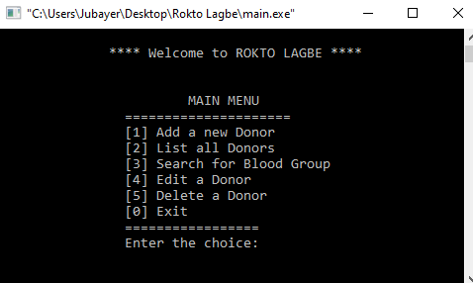

Adding New Donor:

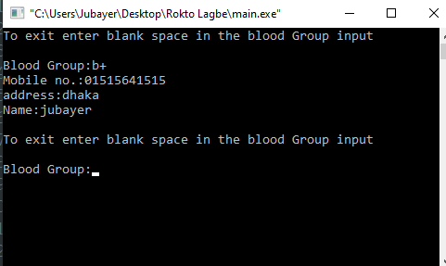

List of all donor:

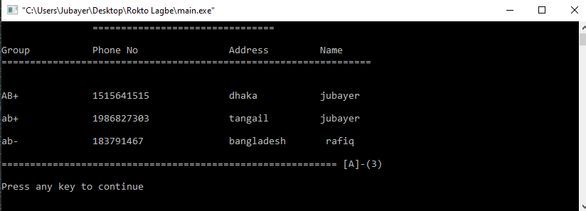

Searching for blood:

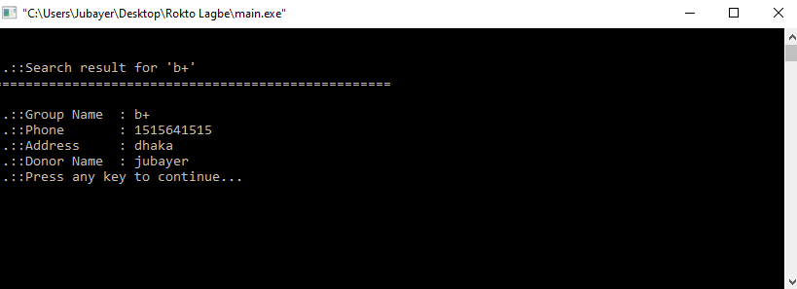

Deleting a donor:

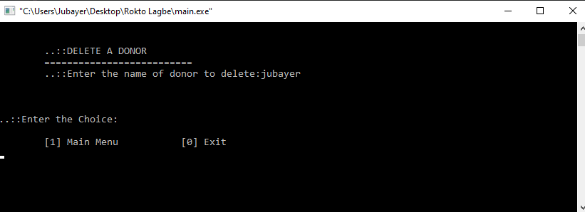

Editing a donor:

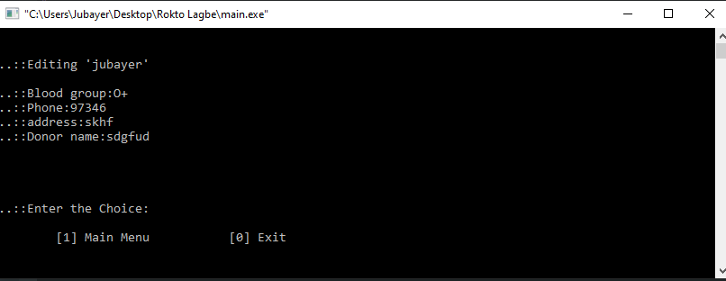

Exit page:

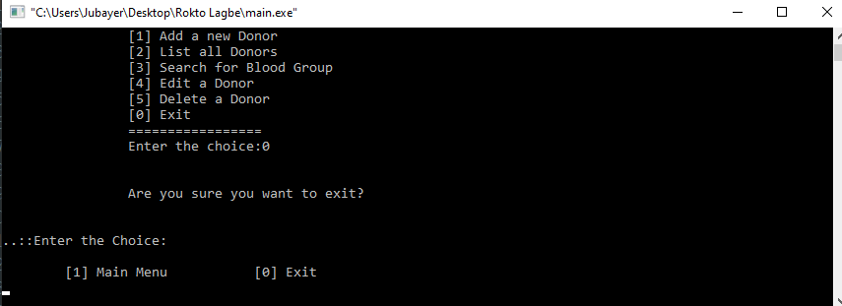

**Conclusion**

For developing this project, we faced some difficulties which are solved by the directions of our honorable supervisor sir. We are still working on it for adding some additional features to make this project more user friendly.